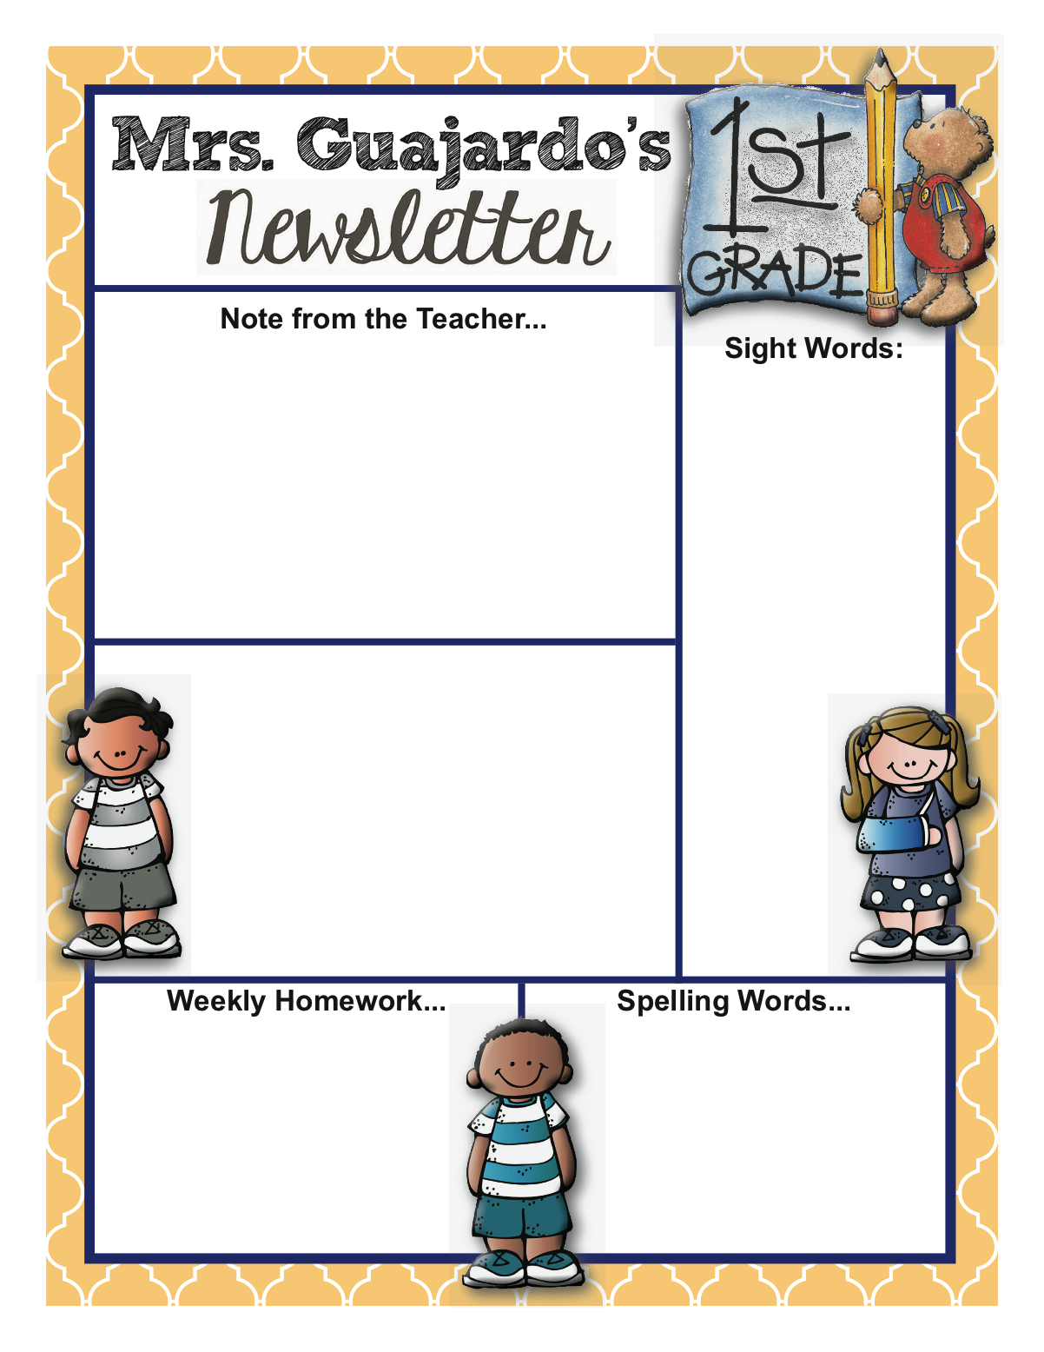

**Summer Homework:**

*Read Read Read!!

*Make a summer Journal and write

about your fun summer activities.

( I’ll have a treat for you if you show it to

me at the beginning of next year!)

* play math games

We had fun and stayed busy learning all year and then, poof…..the end is here! I’m proud of all my students. Each one worked hard and “Bloomed” this year! In addition to their hard work in school, they have had great manners and have been very respectful. Your hard work as a parent is showing and paying off.

Please keep your child reading this summer. Kurth Memorial Library in Lufkin is a great resource for books.

I will miss being a part of their daily lives, but I’m glad I can still see and check up on them occasionally next year!! ( and I will!!)

Have a happy summer!!! You can always email me if you have any reading questions or other concerns.

**HaPpY**

**Birthday!!**

**June 30th- Isaac**

**July 7th- Alexis**

**July 14- Izel**

**July 25- Evelyn**

**This Week’s Plans:**

**Monday: Awards Show @2:00**

**Tuesday- 1st grade Field Day 10:10-12:15**

**Thursday: Last day & Early Release Day**

**Week #36**

May 22-25

2017